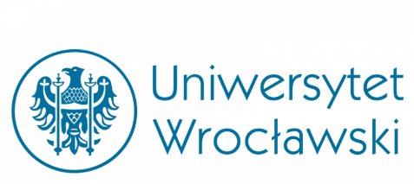
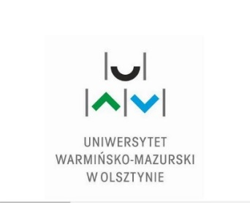

The Faculty of Law and Administration of the University of Warmia and Mazury,
the Faculty of Law, Administration and Economic od the University of Wrocław and the Office for International Relations of the University of Warmia and Mazury in Olsztyn would like to invite all interested students and researchers to an international legal conference to be held on 24 April 2018 on

The challenges in banking in selected EU countries
in the light of current market problems

Languages of the conference will be held in Polish, English, and Italian.
The conference will take place in the building of the Faculty of the Humanities
AULA M.G. DIETRICHÓW ul. Obitza 1 from 9.45am to 1 pm.

9.15. registration
9.45. – opening remarks
I Session - experts
Current problems in the functioning of the banking sector in selected EU countries
9.50 -10.20 - Avv. Pierluigi De Biasi (Studio Legale Gattai Milano)
The various property schemes of banks in Italy (English)
10.25 -10.40 - Prof. UŁ dr hab. Lesław Góral, (Uniwersytet Łódzki)
Effectiveness of bank procedures in preventing money laundering by politically exposed persons. (Polish language - presentation in English)
10.40. 10.55. - Prof. UWM Mariola Lemmonier,
(Uniwersytet Warmińsko – Mazurski w Olsztynie)
Selected compliance problems in banking (English)
10.55. – 11.10. - dr Kamila Naumowicz,
(Uniwersytet Warmińsko – Mazurski w Olsztynie)
Obligations of a bank employee in the field of information protection, (Polish language - presentation in English)

11.10.- 11. 30 A coffee break
II Session experts
Contractual relations between banks and clients
11.40. – 12.05. - Prof. Elisabetta Bani (University of Bergamo)
Ethical finance in Italy, (Italian language Polish translation)

12.05. - 12.20. - Prof. UG dr hab. Anna Dobaczewska, (Uniwersytet Gdański),
Misselling of financial services as an example of conduct offending common decency” (Polish language - presentation in English)

12.20. - 12.35. - dr hab. Edyta Rutkowska-Tomaszewska, (Uniwersytet Wrocławski)
The latest pro-consumer regulations connected with financial services as a challenge for the banking services sector in Poland (Polish language - presentation in English)

12.35-12.50. - dr Beata Pachuca-Smulska,
(Uniwersytet Warmińsko – Mazurski w Olsztynie)
The right to information and education as the basis for consumer protection in the banking services market (Polish language - presentation in English)
12.50 -13.00. - Mgr Magdalena Paleczna, PhD caandidate Uniwersytet Wrocławski
Deficit of ethical behaviour in the consumer credit market in Poland in the light of recent experience (Polish language - presentation in English)

13.00. -13.30. Lunch
III Session - Student and PhD caandidates
will take place in the building of Library room 116
13.35- 13.45 - Tania Piddoncu, Mgr. Michela Loi Università degli Studi di Sassari
Compound Interest. (English)
13.45-14.05 - Filippo Cai, Università degli studi di Pisa
Giuseppe Di Costanzo, Università degli studi di Napoli ‘’Federico II’’
Giovanni Gandino, Università degli studi di Sassari
Ethics in banking. (English)
14.05 – 14.20 - Michał Gornowicz, PhD caandidates
Uniwersytet Warmińsko – Mazurski w Olsztynie
The role of the KNF (the Polish Financial Supervision Authority) in providing criminal law protection on the banking market. (English)
14.20.- 14.35 - Asena Nur KABİL- Shahboz Shoev, University of Yalova/Turkey
How blockhain and bitcoin will reshape the future? (English)
Conclusions.
Closing of the conference.
POSTER SESSIONS
Adrianna Dawidczyk, UWM
Does the amendment of the Payment Services Act protect consumers?
Konrad Wiączek, UWM
The challenges of retail banking.
Martyna Dzikowska, UWM,
Banking services in the Czech Republic.

Scientific Committee
Prof. Elisabetta Bani
dr hab. Edyta Rutkowska-Tomaszewska
dr hab. Mariola Lemonnier, prof. UWM
Dr Beata Pachuca-Smulska
Dr Oksana Cabaj

Organizing committee
Dr hab. Edyta Rutkowska-Tomaszewska
Dr Beata Pachuca-Smulska
Dr Kamila Naumowicz
Dr Oksana Cabaj
Dr Paweł Lewandowski
Mgr Anna Skolimowska
Mgr Michał Gornowicz
Mgr Magdalena Paleczna
Patryk Łubiński
Oskar Łubiński
Martyna Dzikowska
Konrad Wiączek
Adrianna Dawidczyk

